Not for release before March 10, 2020- 8 am Central European Time

News Release
HP Accelerates Digital Printing with New B2 Indigo and PageWide Presses
drupa portfolio powers digital print innovation

News highlights

• Introducing the HP Indigo 100K digital press, a B2-format commercial press, sets a new benchmark in sheetfed productivity with nonstop printing of tens of thousands of B2 duplex sheets every day.
• The B2 HP Indigo 15K digital press sets higher quality standards with new high definition modes and FM screens, support for thick substrates, new inks, expanding the application possibilities of the market-leading HP Indigo 10000 series.
• The HP Indigo 7K, the 19-inch (SRA3+) digital press, offers expanded digital versatility and over 20 specialty inks.
• Entry-level HP Indigo 7eco offers an affordable SRA3+ solution with Indigo’s signature quality and productivity.
• The HP Indigo 90K digital press is an oversized B1 for simplex, roll-fed specialty applications including photo, posters and wallpaper.,
• Announcing the HP PageWide T250 HD with new HP Brilliant™ inks offering new versatility for high-volume commercial applications and application range.
• HP PrintOS^{X} unites cloud platform applications with an AI-driven service and support infrastructure offering solutions and automated processes as a cornerstone to the print factory of the future.

PALO ALTO, Calif., March 10, 2020 — HP Inc. (NYSE: HPQ) today introduced a new commercial digital printing fleet ahead of drupa 2020, setting new industry benchmarks in productivity, print quality and versatility to help print service providers stay ahead of changes in the industry.
HP Indigo announced the new-generation, B2 commercial printing solution, the HP Indigo 100K Digital Press - now the world’s most productive B2 sheetfed solution in the market.¹ The first press in HP Indigo Series 5, the HP Indigo 100K is designed for offset players to adopt highly productive, on-demand digital printing.


“As the commercial industry moves to demanding higher quality and versatile printing, the HP Indigo and PageWide Web Press solutions enable PSPs to easily move from offset to digital, keeping business on track for growth and profitability, with new services offered to customers,” said Santi Morera, general manager and global head of graphics solutions, HP Inc.
Customer beta testing, which commenced before 2019 peak season, is now concluding at customer testing sites globally, including offset print service providers (PSPs).
“HP Indigo 100K performance is above and beyond anything we have experienced with digital printing. The automation innovation is enabling nonstop printing, helping us deliver orders faster to our customers, opening new profit-making opportunities for our business,” said Vincenzo Cirimele, CEO of PressUP, beta tester.
The HP Indigo drupa commercial portfolio also launched the new B2 HP Indigo 15K Digital Press, based on the successful HP Indigo 10000 platform, selling more than a thousand units since launching at drupa 2012. The HP Indigo 15K is engineered to address the broadest variety of customer demands in a highly productive way. It now features greater media support, including for thick substrates, and ink versatility, opening new opportunities for PSPs.
Growing the capabilities of commercial inkjet printing, the HP PageWide T250 HD with HP BrilliantTM inks offers new versatility to expand application range with wider gamut printing on a broad range of papers.
New HP Indigo fleet makes it easier transform to digital production
Five new HP Indigo commercial portfolio presses feature cross-platform innovations that reinvent general commercial printing (GCP) for PSPs. Highlights include:
- The HP Indigo 100K Digital Press offers nonstop duplex digital printing, enables PSPs to deliver more than one million B2 million duplex sheets per month. Printing at 6000 sheets per hour², the new 4-color HP Indigo 100K press delivers significantly higher productivity compared with the HP Indigo 10000 series along with the look and feel of offset. This high performance is enabled by advanced paper handling and offset-like gripper-to-gripper design for precision registration, as well as unique Indigo digital advantages, including color automation, calibration, fast switchover between jobs and media and five-input source feeder.

- The HP Indigo 15K Digital Press brings new quality with high-definition printing and FM screens, and versatility enabled by a wider range of substrates, now offering additional options with up to 600 microns (24 pt.). New inks include ElectroInks Premium White and Invisible Yellow. New high definition FM stochastic screens support increased sharpness for halftone text. The HP Indigo 12000 is upgradeable to new features of the HP Indigo 15K.
- The HP Indigo 7K is a 19-inch (SRA3+) digital press that offers a broader range of high-value digital applications with a media gamut up to 550 microns, with special inks such as HP Indigo ElectroInk Silver, high opacity Premium White, Invisible Yellow for security or unique applications and ElectroInk Easy Release ink for scratch-off applications. New features will be upgrade options to the HP Indigo 7000 series.
- The HP Indigo 7eco is an entry-level press with Indigo quality and productivity offering an economical and sustainable choice to sprint into digital printing.
- The HP Indigo 90K web-fed press supports simplex applications including banners, oversized B1 posters and wallpaper, incorporating new and patented algorithms for continuous print.
- HP PrintOS^{X} unites the cloud platform applications with AI-driven service and support infrastructure to help customers get the most out of their press investment. Based on PrintOS^{X} advanced technology, tools and know-how, customers can start building the Print Factory of the Future and reach operational excellence, automate production and innovate with high-value applications.

“Our philosophy for success is grounded in two key principles – innovation and automation – and how they play together to build a profitable business for customers. All this is underpinned by a view towards reducing waste with a genuine concern for the environment. As we develop our product repertoire, we keep these guiding principles in mind. Our new portfolio reflects a range of products that offer unprecedented productivity, as well as new levels of quality and versatility, to inspire the unbounded creativity of our customers and the brands they serve,” said Alon Bar-Shany, general manager, HP Indigo.

More versatility with the HP PageWide Web Press T250 HD with HP Brilliant Ink™
The new flagship 22-inch continuous inkjet HP PageWide T250 HD, features HP Brilliant Ink and expanded media versatility for high-volume commercial, publishing, transaction, and direct mail applications. Advancements in the new HP PageWide T250 HD, also to be made available as upgrade options, include:
- HP Brilliant Ink delivers high-quality print with eye-catching color, bold reds and dazzling blues with a glossy output. A new CMYK ink set offers an extended gamut, specifically designed to print with high quality on coated and uncoated offset media with one press.
- Expanded application range with the digitally printed HP Optimizer provides smooth color gradients and fills by compensating for batch-to-batch mill variation on coated media while delivering high optical density with reduced show-through on offset uncoated media.
- Maintain quality and productivity via a built-in color vision system and color spectrophotometer. HP’s Quality Image Check vision system monitors print quality in real-time and provides the operator with performance insights while running the press at speed. Capture more business and meet customer deadlines with printing at speeds up to 500 fpm (152 mpm).


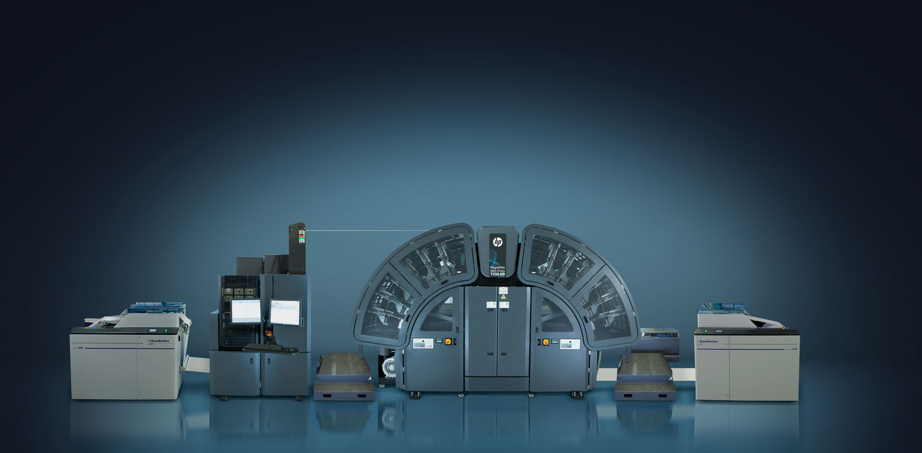
The new HP PageWide T250 HD expands versatility.
To match the productivity of the HP PageWide T250 HD, HP has teamed up with Harris & Bruno to create the H&B ExcelCoat ZRW Web Coater with breakthrough UV and Aqueous coating capabilities for commercial and direct mail applications, delivering new levels of quality, productivity and economics. The coater will be available exclusively through HP.
HP Service Edge expands its offering with the HP PageWide Training Edge subscription service that keeps PageWide customers up to date with operator efficiency. This service fuels business success through ongoing training services. Customers maintain a competitive advantage with operators who are experienced, knowledgeable and armed with the latest technology information and best practices.
“HP continues to innovate with the HP PageWide T250 HD, offering commercial PSPs impressive quality and versatility to profitably grow their businesses on a proven press platform,” said Eric Wiesner, general manager, HP PageWide Industrial Division, HP Inc. “Perfect for commercial print, advertising mail, publishing, transaction, and more, customers who adopt this technology enjoy leading-edge quality, blazing productivity, broad versatility and compelling economics in a press that is upgradable.”
Availability
The B2 HP Indigo 100 and HP Indigo 15K, HP Indigo 7K and HP Indigo 7eco for commercial will all be available at drupa or later in 2020. Value packs with various upgrade options will allow the existing customer base to benefit from new features and capabilities.
The HP PageWide T250 HD will be demonstrated at drupa in June and available later in 2020.

Visit the HP drupa online press kit for more information on today’s announcements and to follow HP’s drupa news.

About HP Inc.
HP Inc. creates technology that makes life better for everyone, everywhere. Through our product and service portfolio of personal systems, printers, and 3D printing solutions, we engineer experiences that amaze. More information about HP Inc. is available at http://www.hp.com.

- Based on a comparison of competing digital B2 solutions as of March 10, 2020.
- 6000 sheets per hour in 3-color Enhanced Productivity Mode (EPM).

Vanessa Forbes, HP  vanessa.forbes@hp.com  www.hp.com/go/newsroom | Nina Gilbert, HP  nina@hp.com

